s
MATHEMATICS LECTURES BY
MANISH KALIA
(B.TECH Delhi College of Engineering)
TOPIC-RELATIONS

A relation is a set of inputs and outputs, often written as ordered pairs (input, output). We can also represent a relation as a mapping diagram or a graph. For example, the relation can be represented as:
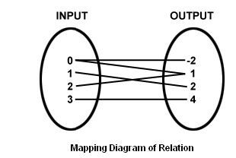
Lines connect the inputs with their outputs. The relation can also be represented as:
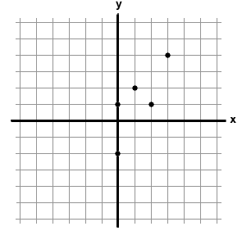

Thus the relation in a set A is a subset of A × A. Thus, the empty set φ and A × A are twoextreme relations.

Types of Relations
1]Empty relation: A relation R in a set A is called empty relation, if no element of A is
related to any element of A, i.e., R = φ ∈ A × A.
2] Universal relation: A relation R in a set A is called universal relation, if each element of A is related to every element of A, i.e., R = A × A.

3] Identity relation: A relation R in a set A is called identity relation, if
R={(a,b):a∈A,b∈A and a=b}

4] Reflexive relation: A relation R is said to be reflexive over a set A if (a,a) € R for every a € R.

Examples:If A is the set of all males in a family, then the relation “is brother of” is not reflexive over A. Because any person from the set A cannot be brother of himself.

The relation R = {(1,1)(2,2)(3,3)} is reflexive over the set A = {1,2,3}.

5] Symmetric relation: A relation R is said to be symmetric if (a,b) ∈ R => (b,a) ∈ R
Examles:If A is the set of all males in a family, then the relation “is brother of” is symmetric over A.Because if a is brother of b then b is brother of a.
If A is the set of mothers and B is the set of children in a family then a relation R on AxB is not symmetric because if a is mother of b then b cannot be mother of a.
6] Transitive relation: A relation R is said to be symmetric if (a,b) ∈ R, (b,c) ∈ R => (a,c) ∈R.
Examles: If A is the set of all males in a family, then the relation “is brother of” is transitive over A.Because if a is brother of b and b is brother of c then a is brother of c.
The relation R = {(1,1)(2,2)(3,3)(1,2)(2,3)} is not transitive over the set A = {1,2,3} because thought (1,2), (2,3) ∈R , (1,3) is not in R.

7] Equivalence relation: A relation R in a set A is said to be an equivalence relation if R is
reflexive, symmetric and transitive.
 Exercise1.1
Q1 Let A be the set of all students of a boys school. Show that the relation R in A given by R = {(a, b) : a is sister of b} is the empty relation and R/ = {(a, b) : the difference between heights of a and b is less than 3 meters} is the universal relation [NCERT]
Q2 Let T be the set of all triangles in a plane with R a relation in T given by
R = {(T₁, T₂) : T1 is congruent to T₂}. Show that R is an equivalence relation.
[NCERT]
Q3 Let L be the set of all lines in a plane and R be the relation in L defined as R = {(L1, L2) : L1 is perpendicular to L2}. Show that R is symmetric but neither reflexive nor transitive. [NCERT]
Q4 Show that the relation R in the set {1, 2, 3} given by R = {(1, 1), (2, 2),(3, 3), (1, 2), (2, 3)} is reflexive but neither symmetric nor transitive. [NCERT]
Q5 Show that the relation R in the set Z of integers given by R = {(a, b) : 2 divides a – b}is an equivalence relation. [NCERT]
Q6 Let A = {3, 5} and B = {7, 11}. Let R = {(a, b): a ∈ A, b ∈ B, a – b is odd}.Show that R is an empty relation from A into B
Q2 Let A = {3, 5}, B = {7, 11}. Let R = {(a, b): a ∈ A, b ∈B, a – b is even}. Show that R is an universal relation from A into B
Q3 Let A = {1, 2, 3} and R = {(a, b): a, b ∈ A, a divides b and b divides a}. Show that R is an identity relation on A.
Q4 Let R be a relation from N into N defined by R = {(a, b): a, b ∈ N and a = 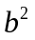}. Are the following true?
- (a, a) ∈ R, for all a ∈ N
- (a, b) ∈ R implies (b, a) ∈ R
- (a, b) ∈ R, (b, c) ∈ R implies (a, c) ∈ R?
Justify you answer in each case.
Q5 Prove that the relation R defined on the set N of natural numbers by xRy 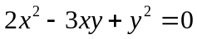i.e., by R = {(x, y): x, y ∈ N and is not symmetric but it is reflexive.
Q6 Let N be the set of natural numbers and relation R on N be defined as xRyx divides y i.e., as R = {(x, y): x, y ∈ N and x divides y}. Examine whether R is reflexive, Symmetric, or transitive.
Q7 Let S be any non empty set and P(S) be its power set. We define a relation R on P(S) by ARB to mean AB; i.e., R= {(A, B): A B}. Examine whether R is (i) reflexive (ii) Symmetric (iii) transitive.
Q8 Prove that a relation R on a set A is (i) reflexive 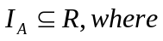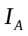= {(x, x): x ∈ A} (ii) symmetric 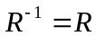.
Q9 Give examples of relation which are
- Neither reflexive nor symmetric nor transitive.
- Symmetric and reflexive but not transitive.
- Reflexive and transitive but not symmetric

Past year CBSE Questions

Q1 Let T be the set of all triangles in a plane with R as relation in T given by 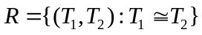,Show that R is an equivalence relation.
[CBSE AI-2008]
Q2 Prove that the relation R on the set A={1,2,3,4,5} given by 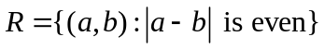is an equivalence relation.
[CBSE Delhi-2009]
Q3 Let Z be the set of all integers and R be the relation on Z defined as R = {(a, b) : a,b∈Z and a – b is divisible by 5.}.Prove that R is an equivalence relation.
[CBSE Delhi-2010]
Q4 Show that the relation S in the set 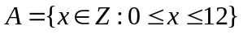given by is an equivalence relation.Find the set of all elements related to 1.
[CBSE AI- 2010]
Q5 State the reason for the relation R ,in the set {1,2,3} given by R={(1,2),(2,1)},not a transitive.
[CBSE AI- 2011]
Q6 Show that the relation R defined by : (a,b)R(c,d)⇒a+d=b+c on the set N is an equivalence relation
[HOTS]

Past year AIEEE/IIT Questions

Q1 Let R={(1,3),(4,2),(2,4),(2,3),(3,1)} be a relation on the set A={1,2,3,4}.The relation R is
[AIEEE-2004]
a) not symmetric
b) transitive
c) a function
d) reflexive

Q2 Let R = {(3, 3), (6, 6), (9, 9), (12, 12), (6, 12), (3, 9), (3, 12), (3, 6)} be a relation on the set A = {3, 6, 9, 12} be a relation on the set A = {3, 6, 9, 12}. The relation is
[AIEEE-2005]
(a) reflexive and transitive only
(b) reflexive only
(c) an equivalence relation
(d) reflexive and symmetric only

Q3 Let W denote the words in English dictionary.Define the relation R by 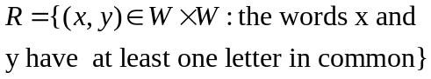Then R is
[AIEEE-2006]

- not reflexive, symmetric and transitive
- reflexive, symmetric and not transitive
- reflexive, symmetric and transitive
- reflexive, not symmetric and transitive
Q4 Let R be the real line .Consider the following subsets of the plane RXR:
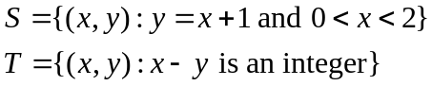
Which of the following statement is true?
[AIEEE-2008]
- T is an equivalence relation on R but S is not.
- Neither T nor S is an equivalence relation on R
- Both S and T are is an equivalence relation on R
- S is is an equivalence relation on R but T is not

Additional Notes:

